CSC139 Operating System

Principles

Spring 2019, Part 1-3

Instructor: Dr. Yuan Cheng

Session Plan

* Operating System Services
* User Operating System Interface
* System Calls
* Types of System Calls
* System Programs
* Operating System Structure

Chapter Objectives

* Identify services provided by an operating system
* Illustrate how system calls are used to provide operating system services
* Compare and contrast monolithic, layered, microkernel, modular, and hybrid strategies for designing operating systems
* Illustrate the process for booting an operating system
* Apply tools for monitoring operating system performance
* Design and implement kernel modules for interacting with a Linux kernel

Operating System Services

* Operating systems provide an environment for execution of programs and services to programs and users
* One set of operating-system services provides functions that are helpful to the user:
  + **User interface** - Almost all operating systems have a user interface (UI).
    - Varies between Command-Line **(**CLI**)**, Graphics User Interface **(**GUI**)**, Batch
  + **Program execution** - The system must be able to load a program into memoryand to run that program, end execution, either normally or abnormally (indicating error)
  + **I/O operations** - A running program may require I/O, which may involve a fileor an I/O device

Operating System Services (cont.)

* One set of operating-system services provides functions that are helpful to the user (cont.):
  + **File-system manipulation** - The file system is of particular interest. Programs need toread and write files and directories, create and delete them, search them, list file Information, permission management.
  + **Communications** –Processes may exchange information, on the same computer orbetween computers over a network
    - Communications may be via shared memory or through message passing (packets moved by the OS)
  + **Error detection** –OS needs to be constantly aware of possible errors
    - May occur in the CPU and memory hardware, in I/O devices, in user program
    - For each type of error, OS should take the appropriate action to ensure correct and consistent computing
    - Debugging facilities can greatly enhance the user’s and programmer’s abilities to efficiently use the system

Operating System Services (cont.)

* Another set of OS functions exists for ensuring the efficient operation of the system itself via resource sharing
  + **Resource allocation -** When multiple users or multiple jobs runningconcurrently, resources must be allocated to each of them
    - Many types of resources - CPU cycles, main memory, file storage, I/O devices.
  + **Accounting -** To keep track of which users use how much and what kinds ofcomputer resources
  + **Protection and security -** The owners of information stored in a multiuser ornetworked computer system may want to control use of that information, concurrent processes should not interfere with each other
    - **Protection** involves ensuring that all access to system resources is controlled
    - **Security** of the system from outsiders requires user authentication, extends to defendingexternal I/O devices from invalid access attempts

A View of Operating System Services

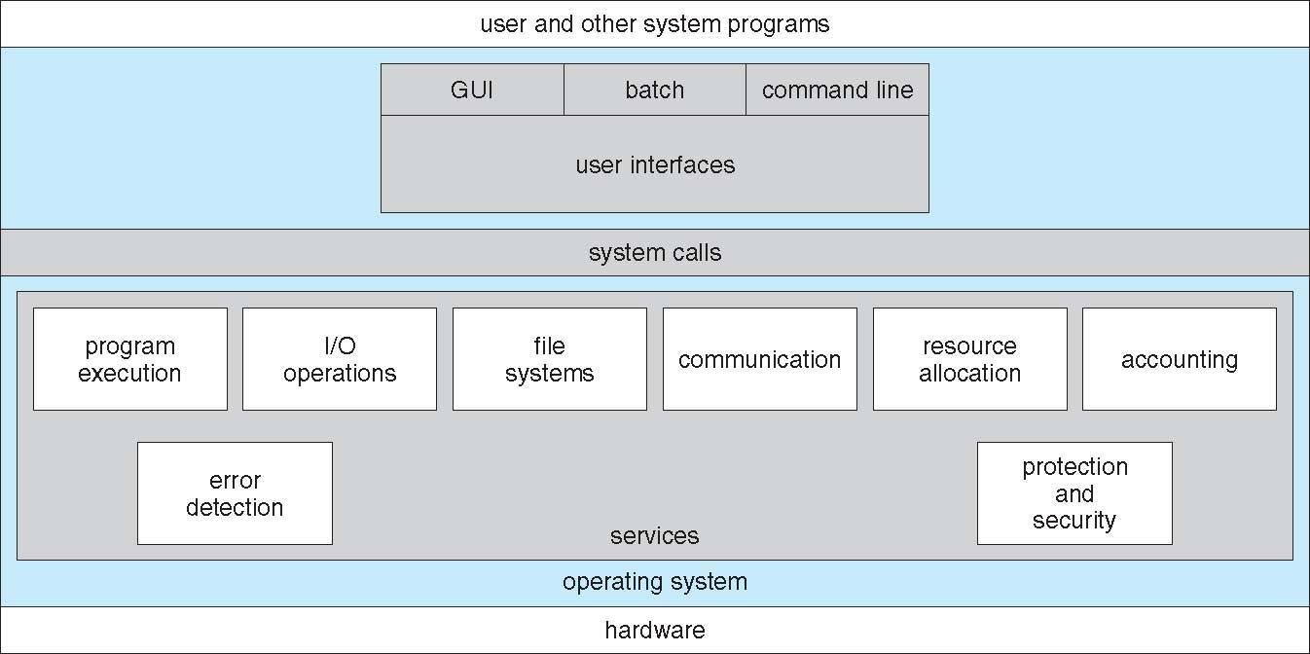

User Operating System Interface - CLI

CLI or command interpreter allows direct command entry

* Sometimes implemented in kernel, sometimes by systems program
* Sometimes multiple flavors implemented – shells
* Primarily fetches a command from user and executes it
* Sometimes commands built-in, sometimes just names of programs
  + If the latter, adding new features doesn’t require shell modification

Bourne Shell Command Interpreter

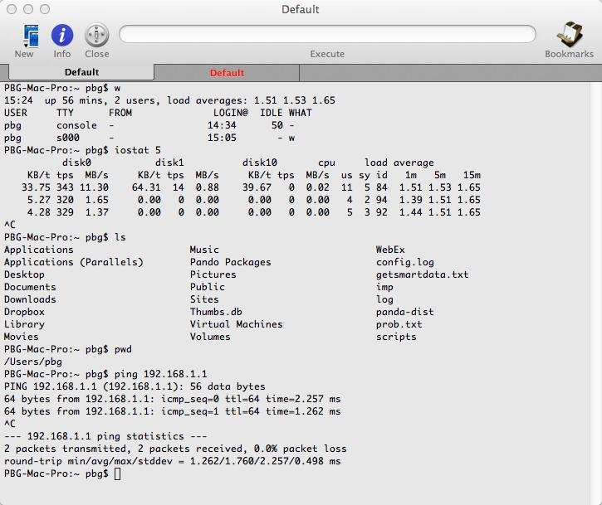

User Operating System Interface - GUI

* User-friendly desktop metaphor interface
  + Usually mouse, keyboard, and monitor
  + Icons represent files, programs, actions, etc
  + Various mouse buttons over objects in the interface cause various actions (provide information, options, execute function, open directory (known as a folder)
  + Invented at Xerox PARC
* Many systems now include both CLI and GUI interfaces
  + Microsoft Windows is GUI with CLI “command” shell
  + Apple Mac OS X is “Aqua” GUI interface with UNIX kernel underneath and shells available
  + Unix and Linux have CLI with optional GUI interfaces (CDE, KDE, GNOME)

Touchscreen Interfaces

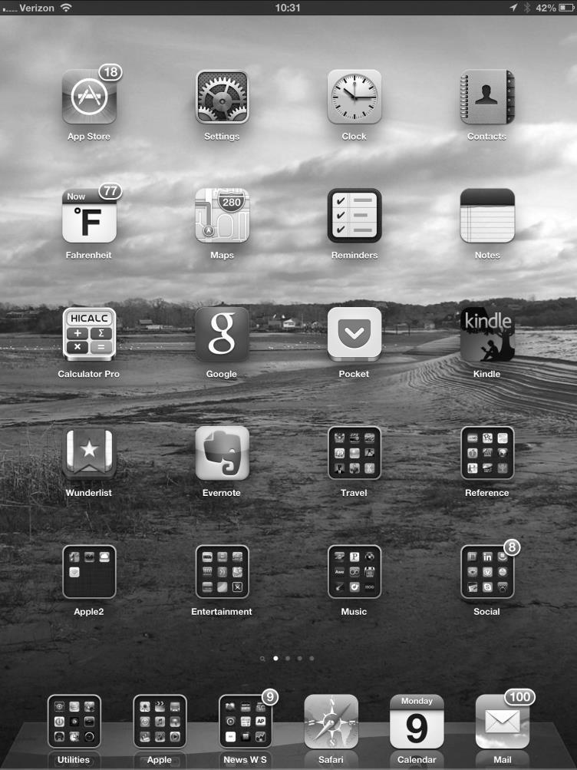

* Touchscreen devices require new interfaces
  + Mouse not possible or not desired
  + Actions and selection based on gestures
  + Virtual keyboard for text entry
* Voice commands.

The Mac OS X GUI

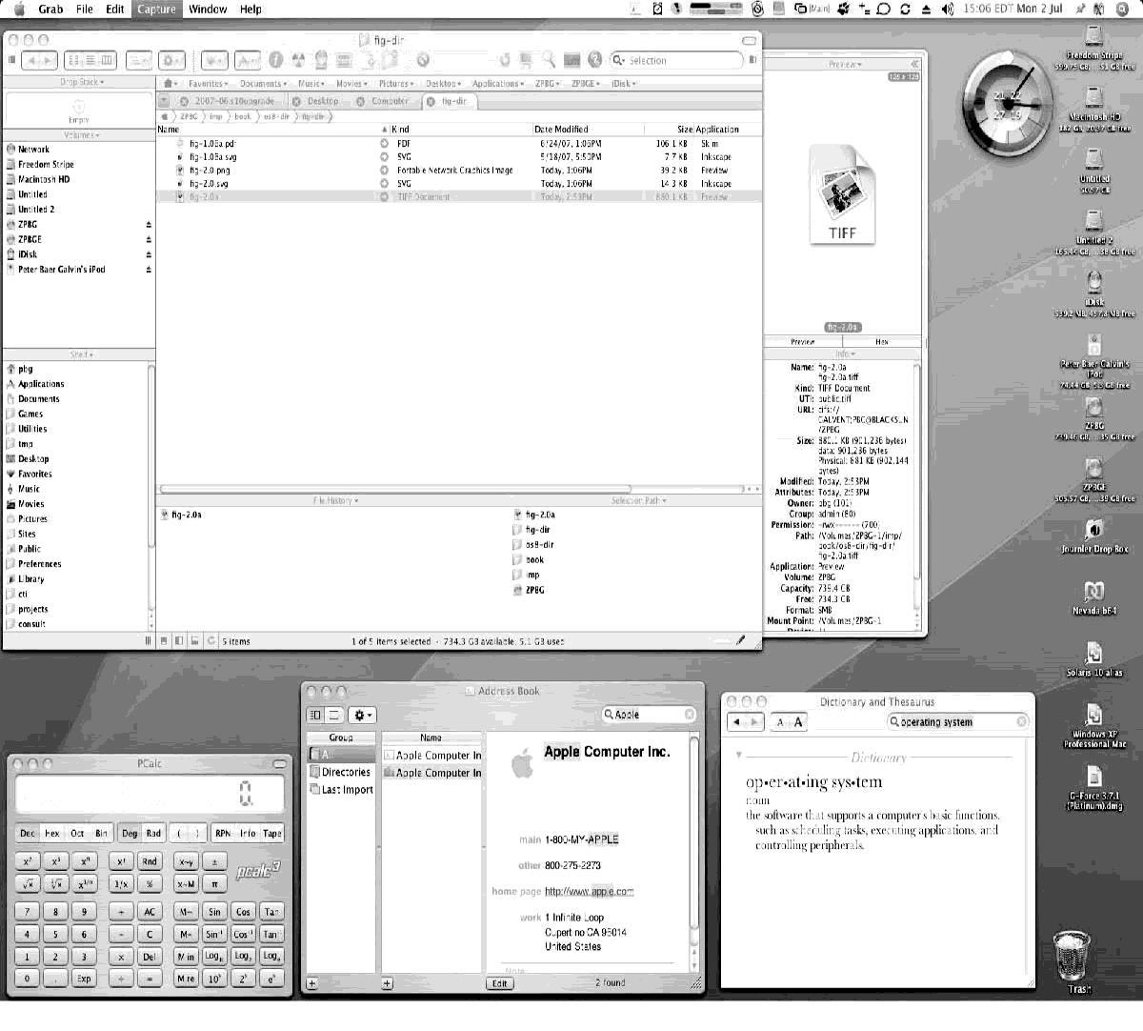

System Calls

* Programming interface to the services provided by the OS
* Typically written in a high-level language (C or C++)
* Mostly accessed by programs via a high-level Application Programming Interface **(**API**)** rather than direct system call use
* Three most common APIs are Win32 API for Windows, POSIX API for POSIX-based systems (including virtually all versions of UNIX, Linux, and Mac OS X), and Java API for the Java virtual machine (JVM)
* Why use API rather than system calls?

Example of System Calls

* System call sequence to copy the contents of one file to another file

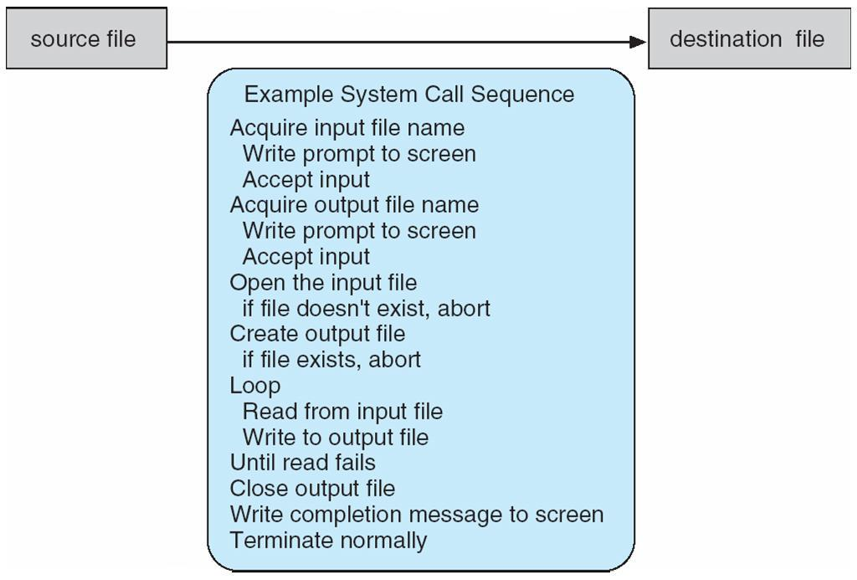

Example of Standard API

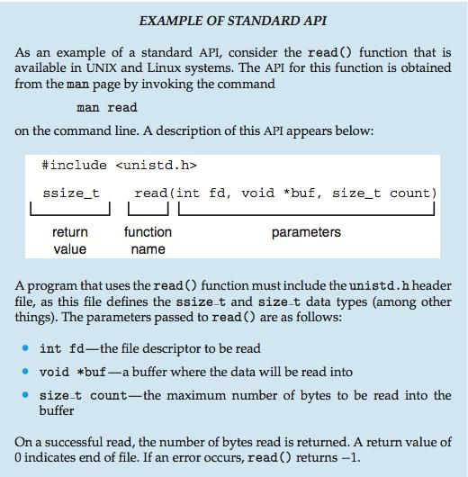

System Call Implementation

* Typically, a number associated with each system call
  + System-call interface maintains a table indexed according to these numbers
* The system call interface invokes the intended system call in OS kernel and returns status of the system call and any return values
* The caller need know nothing about how the system call is implemented
  + Just needs to obey API and understand what OS will do as a result call
  + Most details of OS interface hidden from programmer by API
    - Managed by run-time support library (set of functions built into libraries included with compiler)

API – System Call – OS Relationship

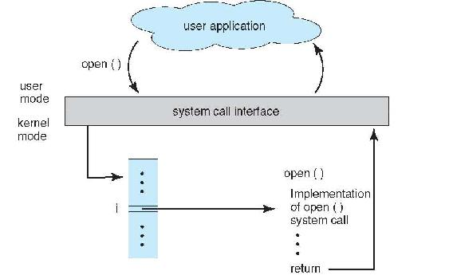

System Call Parameter Passing

* Often, more information is required than simply identity of desired system call
  + Exact type and amount of information vary according to OS and call
* Three general methods used to pass parameters to the OS
  + Simplest: pass the parameters in registers
    - In some cases, may be more parameters than registers
  + Parameters stored in a block*,* or table, in memory, and address of block passed as a parameter in a register
    - This approach taken by Linux and Solaris
  + Parameters placed, or pushed*,* onto the stack by the program and popped off the stack by the operating system
  + Block and stack methods do not limit the number or length of parameters being passed

Parameter Passing via Table

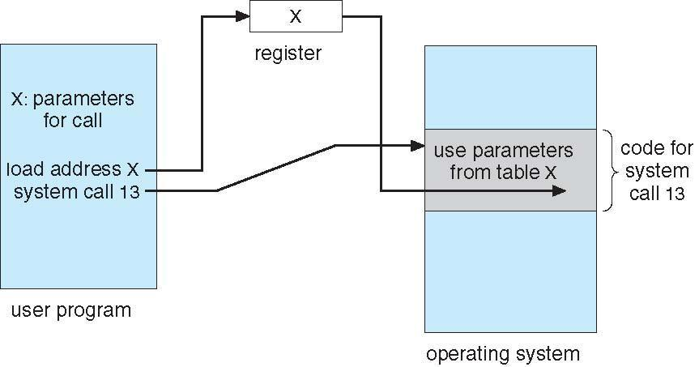

Types of System Calls

* Process control
  + create process, terminate process
  + end, abort
  + load, execute
  + get process attributes, set process attributes
  + wait for time
  + wait event, signal event
  + allocate and free memory
  + Dump memory if error
  + Debugger for determining bugs, single step execution
  + Locks for managing access to shared data between processes

Types of System Calls (cont.)

* File management
  + create file, delete file
  + open, close file
  + read, write, reposition
  + get and set file attributes
* Device management
  + request device, release device
  + read, write, reposition
  + get device attributes, set device attributes
  + logically attach or detach devices

Types of System Calls (cont.)

* Information maintenance
  + get time or date, set time or date
  + get system data, set system data
  + get and set process, file, or device attributes
* Communications
  + create, delete communication connection
  + send, receive messages if message passing model to host name or process name
    - From client to server
* Shared-memory model create and gain access to memory regions
* transfer status information
* attach and detach remote devices

Types of System Calls (cont.)

* Protection
  + Control access to resources
  + Get and set permissions
  + Allow and deny user access

Examples of Windows and Unix System Calls

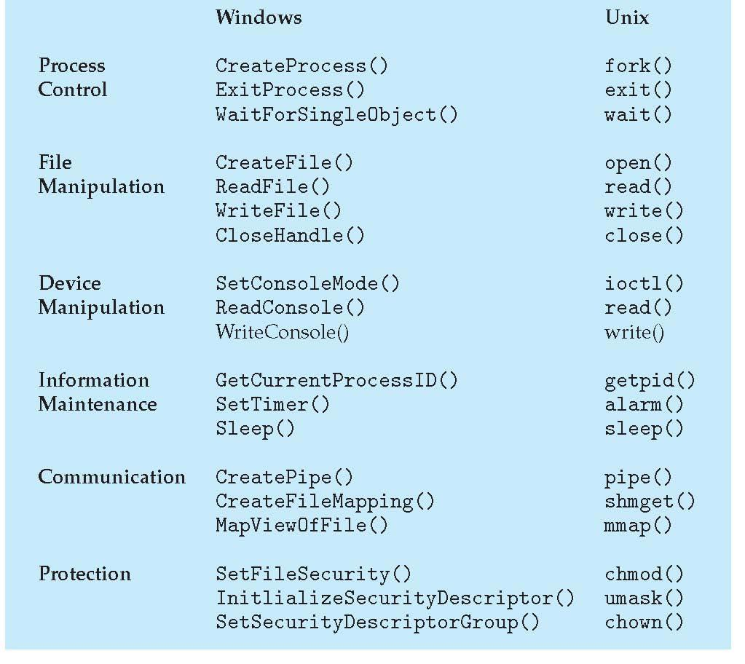

Standard C Library Example

* C program invoking printf() library call, which calls write() system call

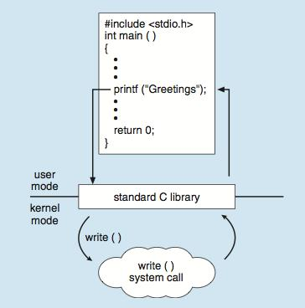

Example: MS-DOS

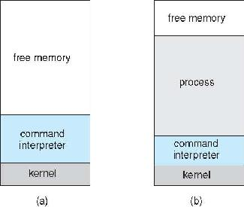

* Single-tasking
* Shell invoked when system booted
* Simple method to run program
  + No process created
* Single memory space
* Loads program into memory, overwriting all but the kernel
* Program exit -> shell reloaded

At system startup running a program

Example: Arduino

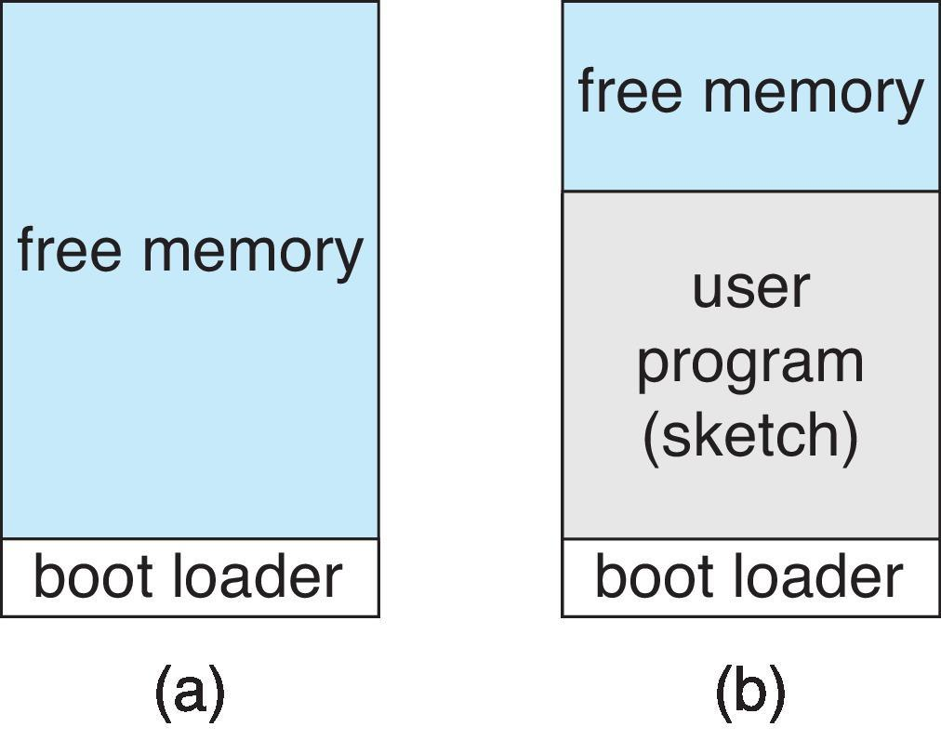

• Single-tasking

• No operating system

• Programs (sketch) loaded via USB into flash memory

• Single memory space

• Boot loader loads program

|  |  |  |  |
| --- | --- | --- | --- |
| • Program exit -> shell reloaded | At system startup | running a program |  |
|  |  |

Example: FreeBSD

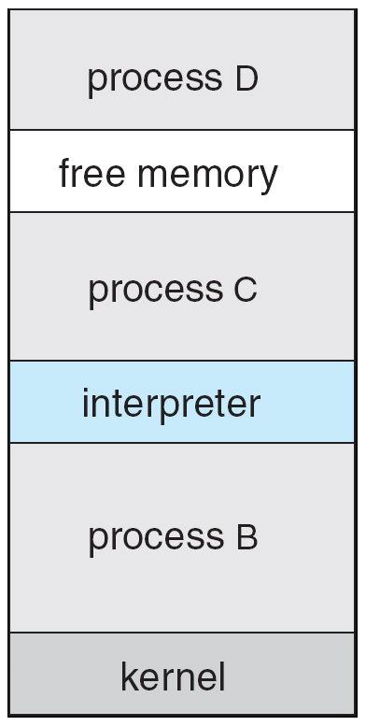

* Unix variant
* Multitasking
* User login -> invoke user’s choice of shell
* Shell executes fork() system call to create process
  + Executes exec() to load program into process
  + Shell waits for process to terminate or continues with user commands
* Process exits with:
* code = 0 – no error
* code > 0 – error code

System Services

* System programs provide a convenient environment for program development and execution. They can be divided into:
  + File manipulation
  + Status information sometimes stored in a File modification
  + Programming language support
  + Program loading and execution
  + Communications
  + Background services
  + Application programs
* Most users’ view of the operation system is defined by system programs, not the actual system calls

System Services (cont.)

* Provide a convenient environment for program development and execution
  + Some of them are simply user interfaces to system calls; others are considerably more complex
* **File management** - Create, delete, copy, rename, print, dump, list, and generally manipulate files anddirectories
* **Status information**
  + Some ask the system for info - date, time, amount of available memory, disk space, number of users
  + Others provide detailed performance, logging, and debugging information
  + Typically, these programs format and print the output to the terminal or other output devices
  + Some systems implement a registry - used to store and retrieve configuration information

System Services (cont.)

* **File modification**
  + Text editors to create and modify files
  + Special commands to search contents of files or perform transformations of the text
* **Programming-language support** - Compilers, assemblers, debuggers and interpreters sometimesprovided
* **Program loading and execution**- Absolute loaders, relocatable loaders, linkage editors, and overlay-loaders, debugging systems for higher-level and machine language
* **Communications** - Provide the mechanism for creating virtual connections among processes, users,and computer systems
  + Allow users to send messages to one another’s screens, browse web pages, send electronic-mail messages, log in remotely, transfer files from one machine to another

System Services (cont.)

* **Background Services**
  + Launch at boot time
    - Some for system startup, then terminate
    - Some from system boot to shutdown
  + Provide facilities like disk checking, process scheduling, error logging, printing
  + Run in user context not kernel context
  + Known as services, subsystems, daemons
* **Application programs**
  + Don’t pertain to system
  + Run by users
  + Not typically considered part of OS
  + Launched by command line, mouse click, finger poke

Operating System Structure

* General-purpose OS is very large program
* Various ways to structure ones
  + Simple structure – MS-DOS
  + More complex -- UNIX
  + Layered – an abstraction
  + Microkernel - Mach

Simple Structure – MS-DOS

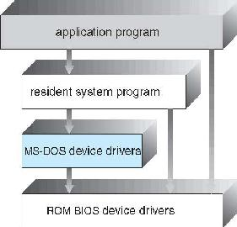

* MS-DOS – written to provide the most functionality in the least space
  + Not divided into modules
  + Although MS-DOS has some structure, its interfaces and levels of functionality are not well separated

Non Simple Structure -- Unix

* UNIX – limited by hardware functionality, the original UNIX operating system had limited structuring. The UNIX OS consists of two separable parts
  + Systems programs
  + The kernel
    - Consists of everything below the system-call interface and above the physical hardware
    - Provides the file system, CPU scheduling, memory management, and other operating-system functions; a large number of functions for one level

Traditional UNIX System Structure

* Beyond simple but not fully layered

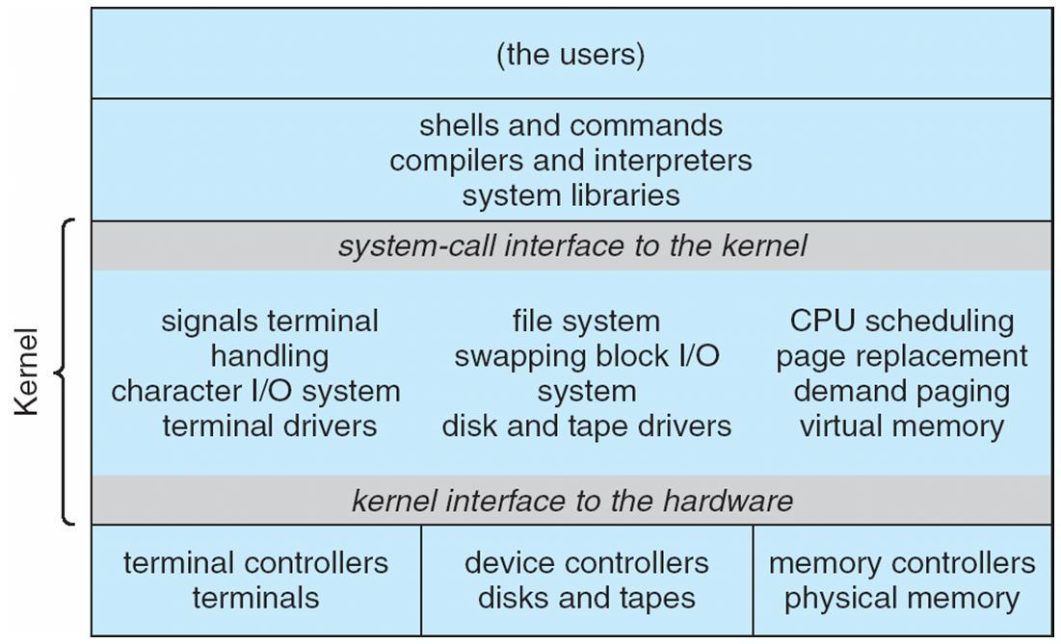

Layered Approach

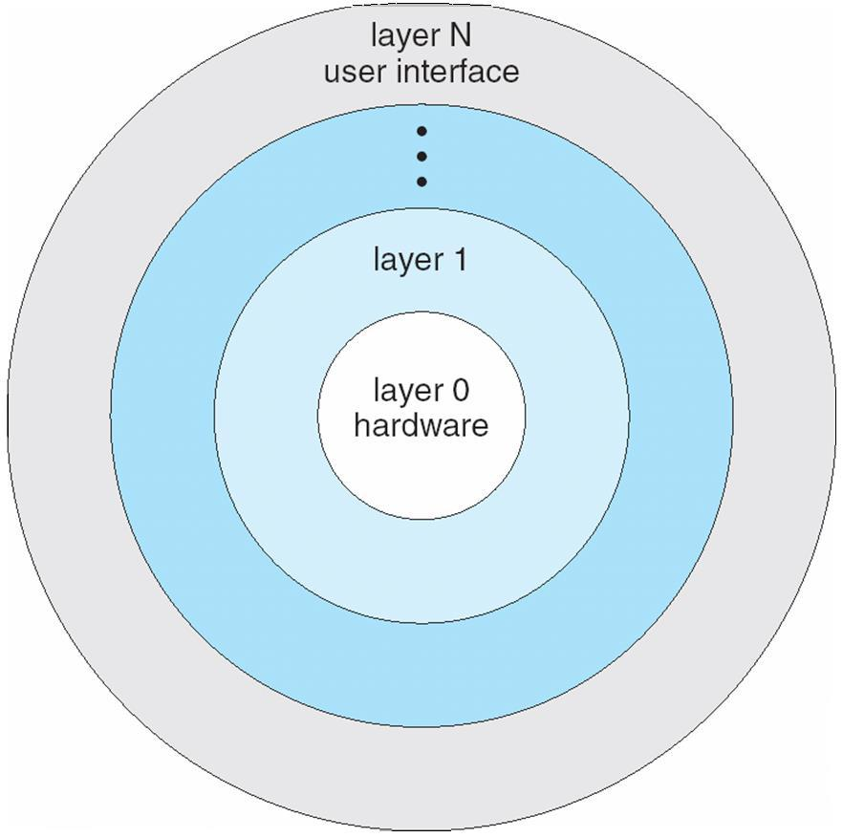

* The operating system is divided into a number of layers (levels), each built on top of lower layers. The bottom layer (layer 0), is the hardware; the highest (layer N) is the user interface.
* With modularity, layers are selected such that each uses functions (operations) and services of only lower-level layers

Microkernel System Structure

* Moves as much from the kernel into user space
* Mach example of microkernel
  + Mac OS X kernel (Darwin) partly based on Mach
* Communication takes place between user modules using message passing
* Benefits:
  + Easier to extend a microkernel
  + Easier to port the operating system to new architectures
  + More reliable (less code is running in kernel mode)
  + More secure
* Detriments:
* Performance overhead of user space to kernel space communication

Microkernel System Structure

|  |  |  |  |  |  |  |  |
| --- | --- | --- | --- | --- | --- | --- | --- |
| Application |  | File |  | Device |  |  | user |
| Program |  | System |  | Driver |  |  | mode |
|  |  |  |  |  |  |  |  |

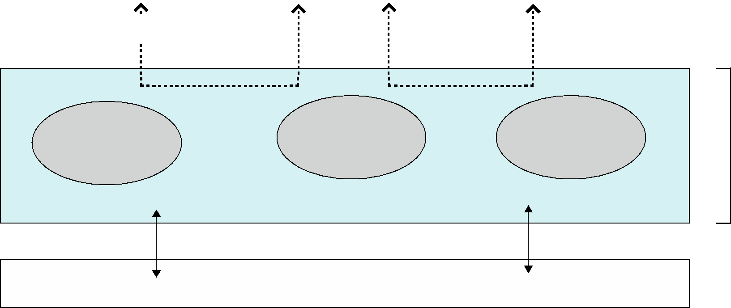

|  |  |  |  |  |
| --- | --- | --- | --- | --- |
|  | messages | messages |  |  |
| Interprocess | memory | CPU | kernel |  |
| managment | scheduling |  |
| Communication | mode |  |
|  |  |  |
|  | microkernel |  |  |  |

hardware

Modules

* Many modern operating systems implement loadable kernel modules
  + Uses object-oriented approach
  + Each core component is separate
  + Each talks to the others over known interfaces
  + Each is loadable as needed within the kernel
* Overall, similar to layers but with more flexible
  + Linux, Solaris, etc.

Solaris Modular Approach

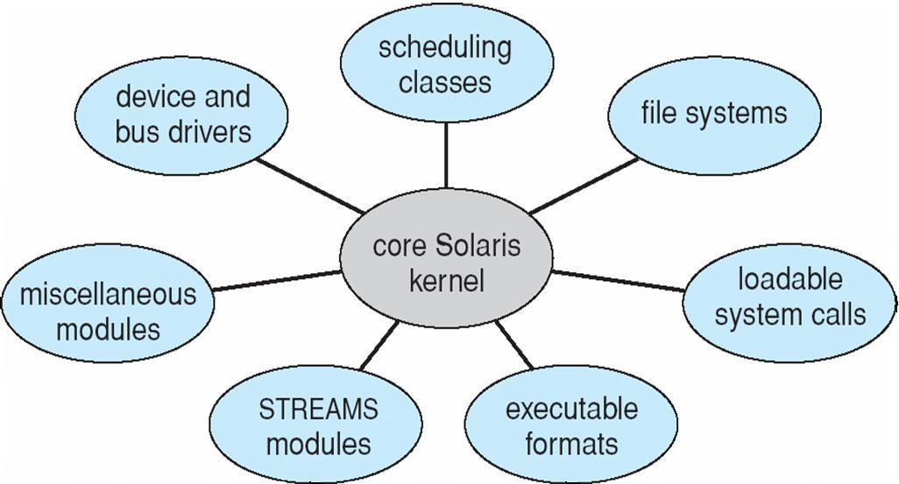

Hybrid Systems

* Most modern operating systems are actually not one pure model
  + Hybrid combines multiple approaches to address performance, security, usability needs
  + Linux and Solaris kernels in kernel address space, so monolithic, plus modular for dynamic loading of functionality
  + Windows mostly monolithic, plus microkernel for different subsystem ***personalities***
* Apple Mac OS X hybrid, layered, Aqua UI plus Cocoa programming environment
  + Below is kernel consisting of Mach microkernel and BSD Unix parts, plus I/O kit and dynamically loadable modules (called kernel extensions)

Mac OS X Structure



|  |  |  |
| --- | --- | --- |
| graphical user interface | Aqua |  |
|  |  |
|  |  |  |

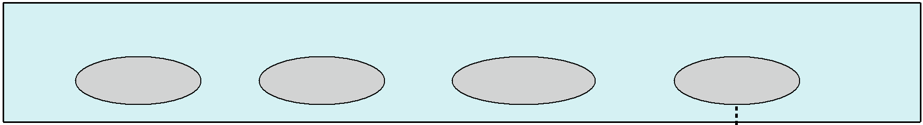

application environments

and services

Java

Cocoa

Quicktime

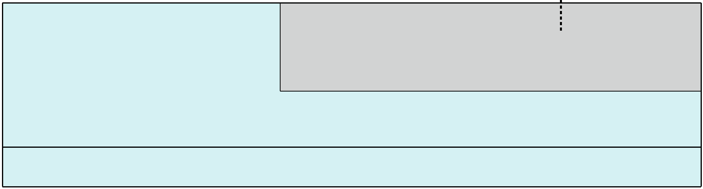

BSD



kernel environment

BSD

Mach

|  |  |
| --- | --- |
| I/O kit | kernel extensions |
|  |  |

iOS

* Apple mobile OS for ***iPhone***, ***iPad***
  + Structured on Mac OS X, added functionality
  + Does not run OS X applications natively
    - Also runs on different CPU architecture (ARM vs. Intel)
  + Cocoa Touch Objective-C API for developing apps
  + Media services layer for graphics, audio, video
  + Core services provides cloud computing, databases
  + Core operating system, based on Mac OS X kernel



Android

* Developed by Open Handset Alliance (mostly Google)
  + Open Source
* Similar stack to IOS
* Based on Linux kernel but modified
  + Provides process, memory, device-driver management
  + Adds power management
* Runtime environment includes core set of libraries and Dalvik virtual machine
  + Apps developed in Java plus Android API
    - Java class files compiled to Java bytecode then translated to executable than runs in Dalvik VM
* Libraries include frameworks for web browser (webkit), database (SQLite), multimedia, smaller libc

Android ArchitectureApplications



Application Framework

|  |  |  |  |  |  |  |  |  |  |  |
| --- | --- | --- | --- | --- | --- | --- | --- | --- | --- | --- |
|  |  | Libraries | | | |  |  | Android runtime | |  |
|  |  |  |  |  |  |  |  |  |  |  |
|  | SQLite |  |  | openGL |  |  |  | Core Libraries |  |  |
|  |  |  |  |  |  |  |  |  |  |  |
|  |  |  |  |  | |  |  |  |  |  |
|  | surface |  |  | media |  |  |  |  |  |  |
|  |  | Dalvik |  |  |
|  | manager |  |  | framework |  |  |  |  |  |
|  |  |  |  |  |  | virtual machine |  |  |
|  |  |  |  |  |  |  |  |  |  |
|  |  |  |  |  | |  |  |  |  |  |
|  | webkit |  |  | libc |  |  |  |  |  |  |
|  |  |  |  |  |
|  |  |  |  |  |  |  |  |  |  |  |
|  |  |  |  |  |  |  |  |  |  |  |

Linux kernel

Exit Slips

* Take 1-2 minutes to reflect on this lecture
* On a sheet of paper write:
  + One thing you learned in this lecture
  + One thing you didn’t understand

Next class

* We will discuss:
  + Processes
* Reading assignment: (skim through before class and continue reading over the weekend)
  + SGG: Ch. 3

Acknowledgment

* The slides are partially based on the ones from
  + [The book site of *Operating System Concepts (Tenth Edition)*: http://os-book.com/](http://os-book.com/)